Experiment 2 — VM Cloning and Network Connectivity
Caption:
Figure 1: Creation and configuration of a customized NAT Network in Oracle VirtualBox
Details to write below the screenshot:
A customized NAT Network named MyNatNetwork was created in Oracle VirtualBox. The IPv4 prefix was configured as 10.0.2.0/24 and DHCP was enabled to assign IP addresses automatically to the connected virtual machines.
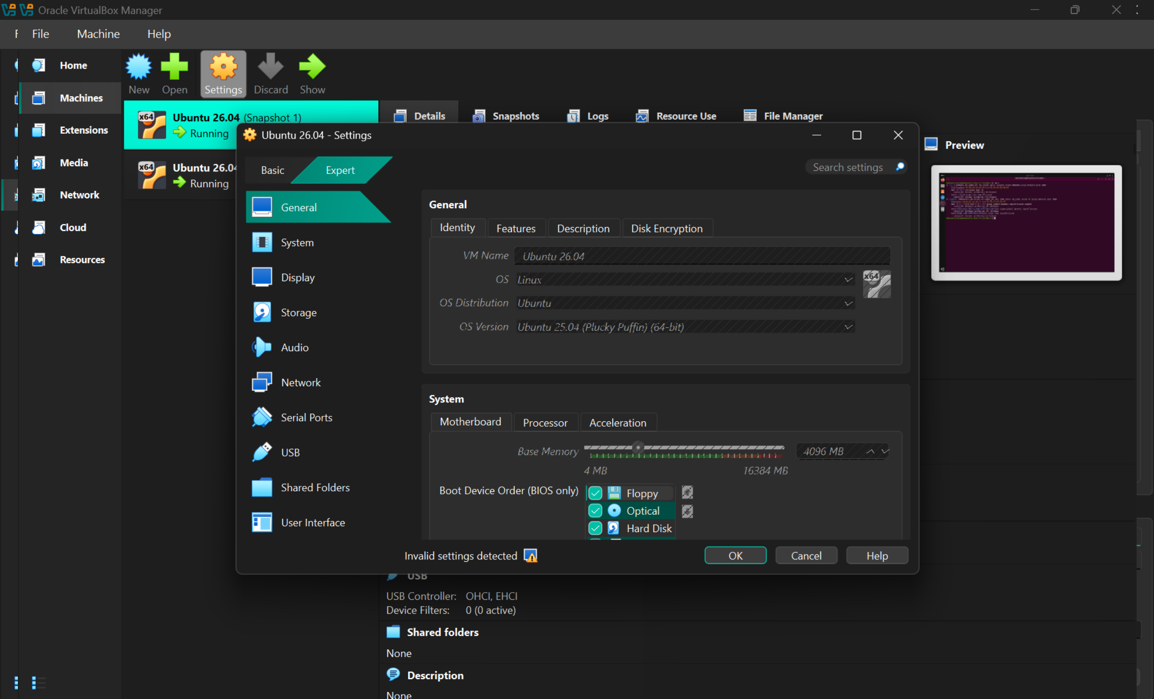
Screenshot 2 — Original VM Settings
Caption:
Figure 2: Network configuration of the original Ubuntu virtual machine
Details:
The network adapter of the original Ubuntu VM was configured to use the customized NAT Network. The network name was selected as MyNatNetwork, and the Virtual Cable Connected option was enabled.

Screenshot 3 — Clone VM Settings
Caption:
Figure 3: Network configuration of the cloned Ubuntu virtual machine
Details:
The cloned Ubuntu VM was configured with the same MyNatNetwork. The network adapter was attached to the NAT Network and the virtual cable was enabled to establish network connectivity.
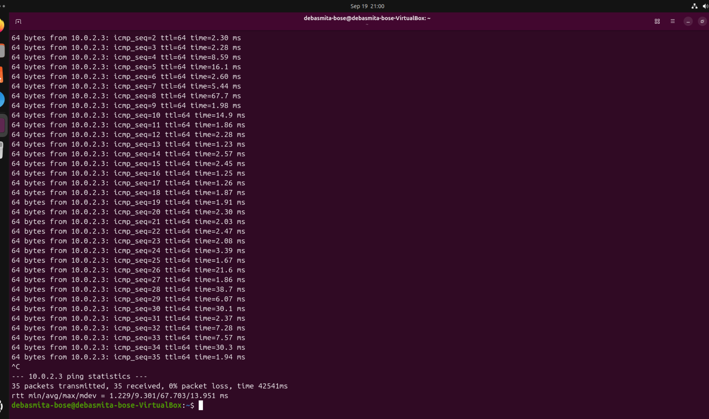
Screenshot 4 — IP Configuration
Caption:
Figure 4: Verification of IP configuration using the ip a command
Details:
The ip a command was used to display the network interfaces and IP configuration of the VM. The enp0s3 interface was active and obtained the IP address 10.0.2.3/24.

Screenshot 5 — Ping Test to VM-2
Caption:
Figure 5: Successful connectivity test from VM-1 to VM-2
Command:
ping 10.0.2.15
Details:
The connectivity between the two virtual machines was tested using the ping command. Successful replies were received from 10.0.2.15, with 0% packet loss, confirming successful communication between the VMs.
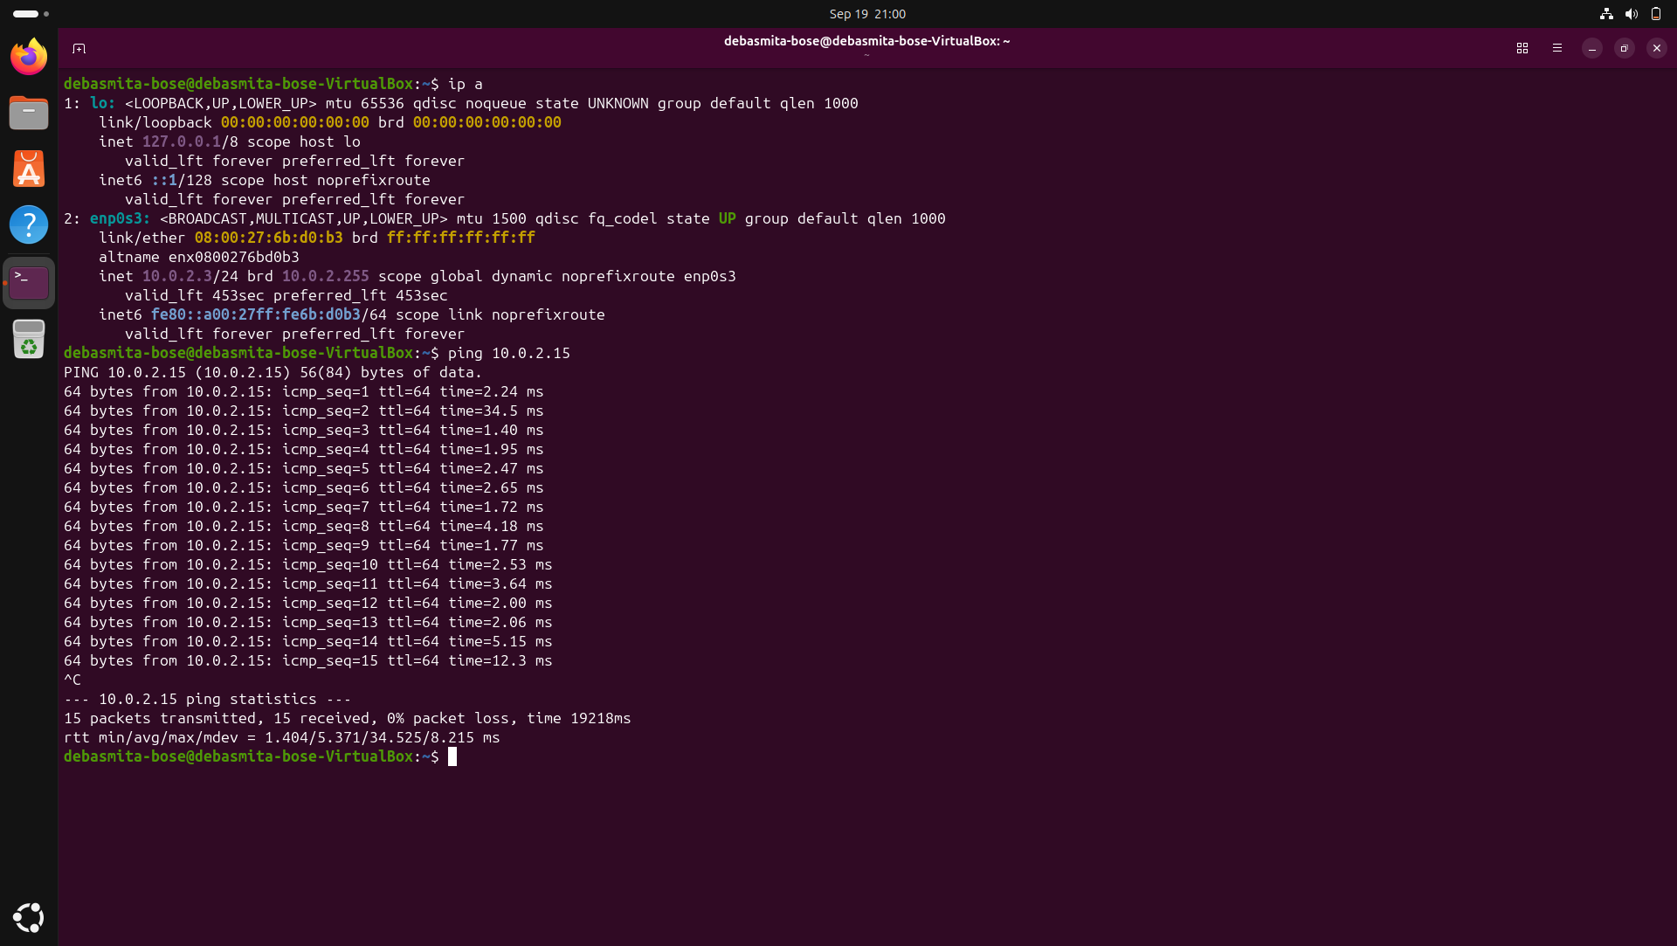
Screenshot 6 — Reverse Ping Test
Caption:
Figure 6: Successful connectivity test from VM-2 to VM-1
Command:
ping 10.0.2.3

Details:
A reverse connectivity test was performed by pinging the IP address of the other VM. The VM received successful replies from 10.0.2.3, with 0% packet loss, confirming two-way communication.
Caption:
Figure 7: MAC address configuration of the virtual network adapters
Details:
The network adapter settings show the MAC address assigned to each virtual machine. The original and cloned VMs use separate virtual network adapters while being connected to the same NAT Network.

